1) Stock and flow was modeled using months as the time unit and .03125 (1/32, or slightly less than daily) as the time step.

a) At 10 years or t = 120, investment = $1314260

b) At 40 years or t = 480, investment = $8698220

c) Increasing time step decreases the frequency at which investment collects interest and results in a lower return overall, and a less accurate representation of true continuous compound interest. For example, increasing time step from .03125 to 1 (thereby turning the turning the interest compounding from about daily to monthly) results in the 40-year investment being $8642860 instead of $8698220, which is a difference of over $50000.

2) The model was configured and simulated as required, and the following output graphs were generated

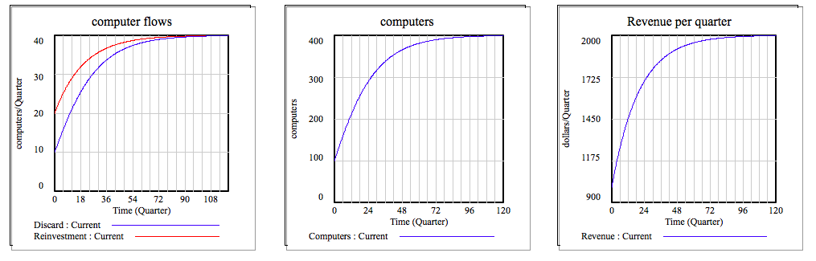

At first the reinvestments into new computers out paces the amount of computers each quarter.

The system reaches an equilibrium when the number of computers = 400; at that point the rate of discard and disinvestment equalize and the net change in computers is zero. This corresponds to a revenue of 2000 per quarter.